Lab 2: Containerization & Kubernetes Orchestration
Task 4: Containerize a sample application using Docker

1. Objective
Write a Dockerfile for a Flask app, build the image, run the container and document the image layers and behaviour.

2. Application
app.py exposes GET / (welcome message, hostname, visit counter stored in /data/counter.txt) and GET /health.

3. Dockerfile and build
# Layer 1: base image
FROM python:3.12-slim

# Layer 2: metadata / working directory
WORKDIR /app

# Layer 3: dependency manifest copied first so pip install is cached
# independently of application code changes
COPY requirements.txt .

# Layer 4: install dependencies
RUN pip install --no-cache-dir -r requirements.txt

# Layer 5: copy application source
COPY app.py .

# Layer 6: create data directory used for storage demo
RUN mkdir -p /data

# Metadata: document the port the app listens on
EXPOSE 5000

# Layer 7: default command to run the container
CMD ["python", "app.py"]

docker build -t lab2-python-app:1.0 app

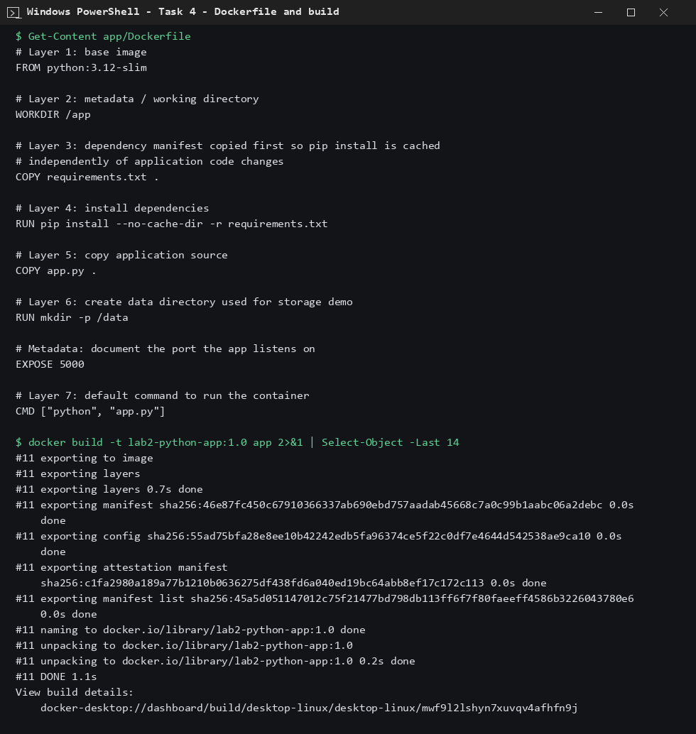
Figure 1: Dockerfile and image build

4. Run, layers and behaviour
docker run -d --name lab2-app -p 5000:5000 lab2-python-app:1.0
curl localhost:5000/
curl localhost:5000/health
docker history lab2-python-app:1.0

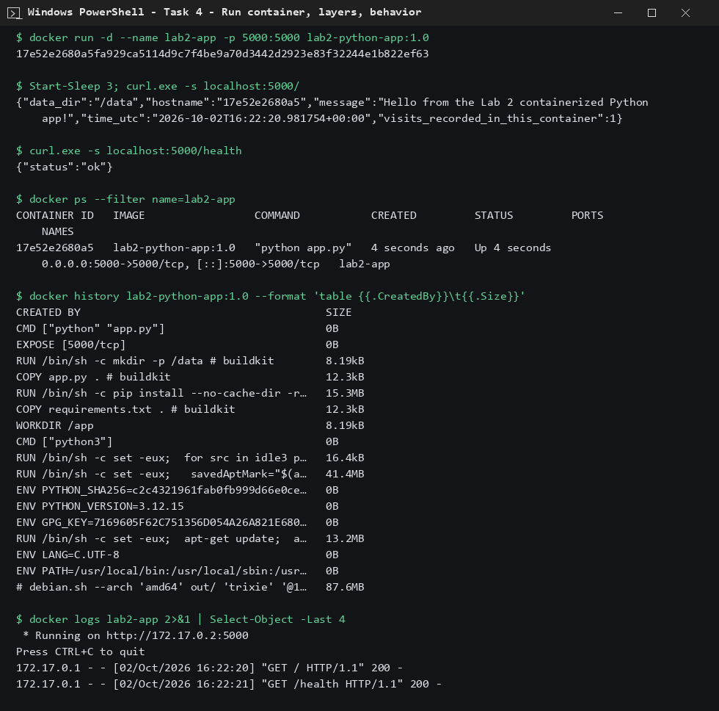
Figure 2: Container running, endpoints tested, image layers

5. Layer description
- FROM python:3.12-slim: base OS and Python (largest layers).
- WORKDIR, COPY requirements.txt: small metadata/file layers.
- RUN pip install: installs Flask (15.3 MB).
- COPY app.py, RUN mkdir /data: application code and data directory.
- EXPOSE and CMD: metadata only (0 B).

6. Conclusion
The image was built, the container ran and served requests, and docker history shows each Dockerfile instruction as a layer.

